A000-Eur-Bulgaria-Stara Zagora-Bust-Female-Smiling-Ceramic-6th Millennium BCE-Neolithic

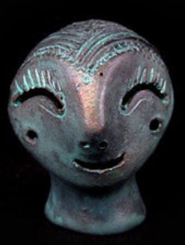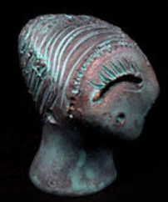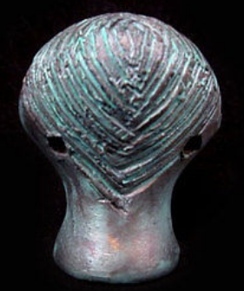

Fig. 1. Bulgaria-Stara Zagora-Bust-Ceramic-6th Millennium BCE-Neolithic

**Case no.: 1**

**Accession Number:** A000

**Formal Label:** Bulgaria-Stara Zagora-Bust-Ceramic-6th Millennium BCE-Neolithic

**Display Description:**

A hollow ceramic with suspension holes on either side suggesting its use was as a pendant. Images of anthropomorph masks such as this one may have been created for the kuker festival when strange, masked creatures were invoked to bless a fruitful harvest for the New Year. These hollow ceramic masks appear as though they were miniatures for such festivals.

**LC Classification:** DR98 S83

**Date or Time Horizon:** 6th Millennium BCE-Neolithic

**Geographical Area:** Stara Zagora, Bulgaria

**Map:**

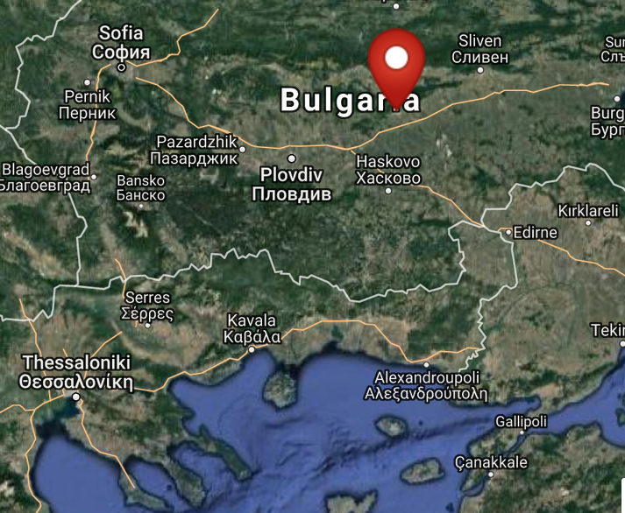

Fig. 2. Map of location of Stara Zagora, Bulgaria. From <http://latitude.to/lat/42.42604/lng/25.63356>

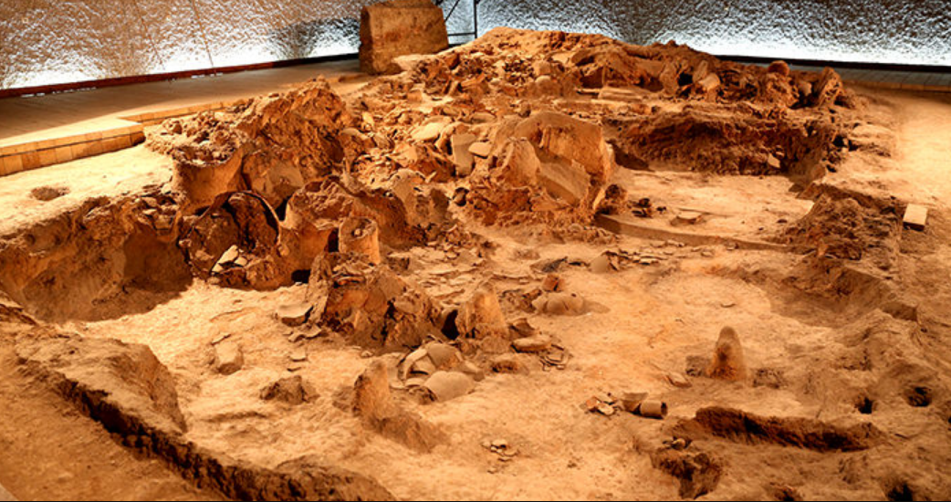

Fig. 3. Neolithic House, Stara Zagora regional Historical Museum, Bulgaria. http://www.getmetravelled.com/wp-content/uploads/2015/08/Neolithic-Dwellings-Museum_Stara_Zagora_Bulgaria.jpg

**GPS coordinates:** 42º25'33.74" N 25º38'0.81" E

**Cultural Affiliation:** 6th Millennium BCE-Neolithic

**Medium:** Original, ceramic; replica is made of a ceramic material and painted with special varnish and paint.

**Dimensions:** H 45, W30 mm

**Weight: 16 g**

**Condition: ceramic replica**

**Provenance:** original, Stara Zagora regional Historical Museum

**Discussion:**

The original wasfound in the ruins of a Neolithic settlement in the region of Stara Zagora, Bulgaria the Original is on display in the Archaeological Museum in Stara Zagora.

**References:**

Gaul, James Harvey. [1948. *The neolithic period in Bulgaria : early food-producing cultures of Eastern Europe*](http://www.worldcat.org/title/neolithic-period-in-bulgaria-early-food-producing-cultures-of-eastern-europe/oclc/1001170812&referer=brief_results)*.*  Cambridge (Mass.): Peabody Museum.

[Krauß](http://www.worldcat.org/search?q=au%3AKrau%C3%9F%2C+Raiko.&qt=hot_author), Raiko; [Nedko Elenski](http://www.worldcat.org/search?q=au%3AElenski%2C+Nedko.&qt=hot_author" \o "Search for more by this author); [Bernhard Weninger](http://www.worldcat.org/search?q=au%3AWeninger%2C+Bernhard.&qt=hot_author); [Lee Clare](http://www.worldcat.org/search?q=au%3AClare%2C+Lee.&qt=hot_author); [Canan Çakirlar](http://www.worldcat.org/search?q=au%3AC%CC%A7akirlar%2C+Canan.&qt=hot_author" \o "Search for more by this author); [Petǎr Zidarov](http://www.worldcat.org/search?q=au%3AZidarov%2C+Peta%CC%8Cr.&qt=hot_author" \o "Search for more by this author). 2014. “Beginnings of the Neolithic in Southeast Europe : the early Neolithic sequence and absolute dates from Džuljunica-Smǎrdeš (Bulgaria),” *Documenta Praehistorica. Poročilo o raziskovanju paleolitika, neolitika in eneolitika v Sloveniji. Neolitske študije = Neolithic studies*, 41:51-77.

Todorova, Khenrieta. 1978. *The eneolithic period in Bulgaria in the fifth millennium B.C*. Oxford: British Archaeological Reports.